* *Proto-paper, to get an early product from the drought/ranch/insurance analyses out, show some progress from both WWA and EL support, help with next proposals. Write so as to not interfere with more detailed papers on the drought/index/insurance analyses and more searching study of drought impacts/decisions/insurance.*
* *Potential Authors: Travis, Tuccillo, Carney, Shrum*
* *Journal targets: Rangelands; Range Ecosystem Mangt if we want to stay in the range community, or Natural Hazards, Weather and Climate Extremes, etc.*

# Ranching through drought:

# The challenge of making decisions under weather, climate, and market uncertainty

## Introduction

## The Ranch-Drought Decision Problem

Livestock ranching on semi-arid rangelands involves some of most complex decision making of any natural resource production system and studies of rancher responses to weather and climate variation may not only illuminate the challenges in that industry but offer lessons for complex decision-making in other climate-sensitive sectors as well as add to our understanding of universal problems in decision-making under uncertainty. Pastoralism is an especially adaptable natural resource production system, with complex interactions among weather/climate, range condition, cattle and land management, socio-economics and policy----it has long been studied as a complex socio-ecological system (Turner et al), and as exemplar of human adaptation to environmental variability.

The key threat in the western U.S. range livestock system is drought, which reduces forage production that in turn can reduce cow and calf weights, and sales revenue. Drought may also affect markets in multiple ways, especially if widespread drought causes many producers to cull their herds and thus flood the market, perhaps while also raising feed prices. Unlike crop farmers, ranchers can adjust plans at any time in the annual cycle, and they can call on a wide spectrum of adjustment options: selective or even wholesale weaning, herd culling and early sale, purchasing additional feed to make-up short-falls of forage production, requesting additional time on public lands, or renting more pasture, all under uncertainty about future climate, forage production and market conditions. During drought short-term herd management decisions must be calibrated to changing notions of near- and long-term range and market conditions (with markets affected by decisions by other ranchers also facing drought), all in the context of possible negative outcomes both in terms of economic returns and range ecosystem conditions.

Each drought adaptation choice has implications for the ranch enterprise, as well as potentially lasting effects on rangeland ecosystems. In terms of decision theory, producers operate in two major realms: expected utility under uncertainty (especially about climate, range, and market conditions), and strategic or game behavior in terms of anticipating the behavior of other producers (whose choices affect the market), feed markets (e.g., the changing price of hay), and the government (which can offer supports like subsidized feed or other drought emergency programs). Producers navigate this complexity with a mixture of tradition, intuition, analysis, and external advice, mediated in theory by their risk perception and risk aversion.

The daunting drought decision challenge was made clear in an Associated Press news report during the 2011-2012 drought that caused the largest sell-off of the nation’s cattle herd in history:

A [Kansas rancher] sold 20 pairs of cows and calves a few weeks after drought had sucked his pastures dry and no rain was in the forecast. He sold 20 more pairs Friday. [The rancher] spent years meticulously breeding his cows to improve the genetics each generation, but with Kansas in one of the worst droughts in decades, he’s struggling to find enough grazing to feed 300 cows, plus their calves. He hopes to get by with selling only a quarter of his herd, but there are no guarantees with the drought expected to linger through October. (Hegeman, 2012)

The article reported on the large sell-off that depressed beef prices, bringing the national inventory to a 40-year low, and described the awkward cycle in which ranchers *en masse* cull herds to save their pastures, selling into flooded markets at lowering prices, but later buying replacement animals at higher prices. One obvious ranching strategy to buck the trend is also illustrated in a quote: “If you can figure out a way to hang on to them at a reasonable cost until the drought is over, it typically pays you pretty well.” Holding on means finding alternative feed and pasturage options. But the urge to hold on, even as drought worsens, is often cited as a cause of long-term range ecosystem degradation (Knutson and Haigh, 2013; National Drought Mitigation Center, 2011) ), and much of the drought advice provided to ranchers warns against that strategy: … In the worse case ranchers may find themselves degrading range productivity, buying expensive feed, renting pasturage at inflated prices or, finally, selling into a market flooded by other producers also culling their herds (Hegeman, 2012). Even worse, those forced to market more than they would have in normal circumstances found themselves paying a premium to rebuild herds in the drought’s aftermath (Gee, 2015). In a subtle effect of the regret function, ranchers that were slow to de-stock may also be slow to rebuild their herds as drought eases. In 2015, with the industry in recovery, the Wall Street Journal could still find aversion to climate risks, quoting a rancher who was waiting to expand his herd back to its pre-drought levels: “’I’m not willing to spend $2,000 or $2,500 for a bred heifer and not know if I can make a profit next year,’ Mr. Lieb said. ‘I’m not sure the drought is over’” (Gee, 2015). It is no wonder that one extensive set of guides to ranch-drought management is sprinkled with suggestions for maintaining mental and physical health, and family well-being, through such tough choices (Knutson and Haigh, 2013; National Drought Mitigation Center, 2011).

Of course such loss scenarios only play out if, indeed, drought continues, and decision theory (as well as producers) recognizes that uncertainty about even near-term future conditions---Will the drought continue? Worsen?----means that it is only in hindsight, with knowledge that the drought did, indeed, continue and worsen, that early adaptive decisions seem justified. Such advice may neglect expected value theory and belittle the regret function ( ): the decision-maker’s assessment now of how they will feel about their choices if they are eventually proved as having been unnecessary. Absent skillful forecasts of drought conditions over future months and seasons, the producer who chooses no action in the early stages of drought may well be wise, especially since most dry spells do not become extreme droughts.

# Drought Decision Analysis

The core problem laid out above, how best to manage livestock and land in shifting weather and market conditions, has been extensively studied, and economic and ecologic analysis ( ) has been translated into a wealth of advisory literature ( ) and decision support tools ( ). As with agricultural economics research more widely, concepts of risk and risk management entered the range economics literature in the 1960s (Committe on Economics of Range Use and Development, 1966), and this interest led to efforts to find optimal decisions in ranch operations (e.g., (Rodriguez and Taylor, 1988). A body of detailed analysis of ranch decision making has thus accumulated (Carande et al., 1995; Ritten et al., 2010a; Ritten et al., 2010b), and results have pointed toward the value of dynamic, flexible, and responsive decisions, especially during droughts. Still, several scientific and operational questions adhere to the problem of adapting ranching to weather and climate variability. One important, over-arching question has run through the range-livestock research literature for many years: whether in general it is better to face weather and forage variability by the oft-suggested conservative long-term stocking rate vs. varying herd size frequently to match climate/range conditions (see, for example, Stafford Smith (1992); (Torell et al., 2010). Recent drought strategy advice has shifted toward dynamic adaptation, thus putting more emphasis on rapid response and informed decision-making, along with nimble financial management, a strategy presumably enabled by better monitoring, data, forecasts, and analytical capacity.

Drought risk management and decision tools aimed at livestock producers have burgeoned in recent years, and provide a solid base for further developing decision making under uncertainty approaches. These include, for example:

* “Rangeland Decision-Making Project: <http://www.ars.usda.gov/Research/docs.htm?docid=23087>
* “Managing Drought Risk on the Ranch”: <http://drought.unl.edu/ranchplan/Overview.aspx>
* South Dakota drought tool: <http://www.nrcs.usda.gov/wps/portal/nrcs/main/sd/technical/landuse/pasture/>
* Similar drought calculator for North Dakota: <http://nrrc.ars.usda.gov/DCND/> which includes a probability tool to judge likelihood of getting future precipitation that would make up a projected forage deficit.
* Enterprise decision tools developed by Extension services across the region; for example: “Strategies for Beef Cattle Herds During Times of Drought, v2012” (Jeffrey E. Tranel, Rod Sharp, & John Deering), and “Buy Hay sell Cows” (Jeffrey E. Tranel and Stephen Koontz); see: <http://www.coopext.colostate.edu/abm/decision.htm>
* The relevant agricultural risk management and decision-making tools and scenarios that are part of the “Right Risk” (<http://www.rightrisk.org/>) and “Risk Navigator SRM” (<http://www.risknavigatorsrm.com/default.aspx>) suite of risk assessment and decision making aids; also described in Hoag (2010).
* the ARS Adaptive Grazing Management Experiment at the Central Plains Experimental Range: <http://www.ars.usda.gov/Main/docs.htm?docid=24218>

## The Decision Structure

At the center of the ranch-drought decision problem is the choice of alternative responses and their outcomes, and this has been the focus of the research and extension literature as well. State extensive services, and drought management entities like the National Drought Mitigation Center (see also NIDIS), provide planning and decision tools aimed right at this crux. We adapted one such ranch-drought decision tool for the analysis reported below. Drought risk assessment tools are another important ingredient, including drought monitoring and forecasting available from NIDIS, and the critical link between drought and range productivity made in the suite of “Drought Calculators” developed by the USDA-ARS (Dunn et al; see www…). A new drought risk management tool aimed specifically at the range livestock industry has also become available in recent years, the USDA’s RPF index insurance program.

We combine these elements in decision simulation model (Fig. 1) designed as both a research tool and as a potential decision aid.

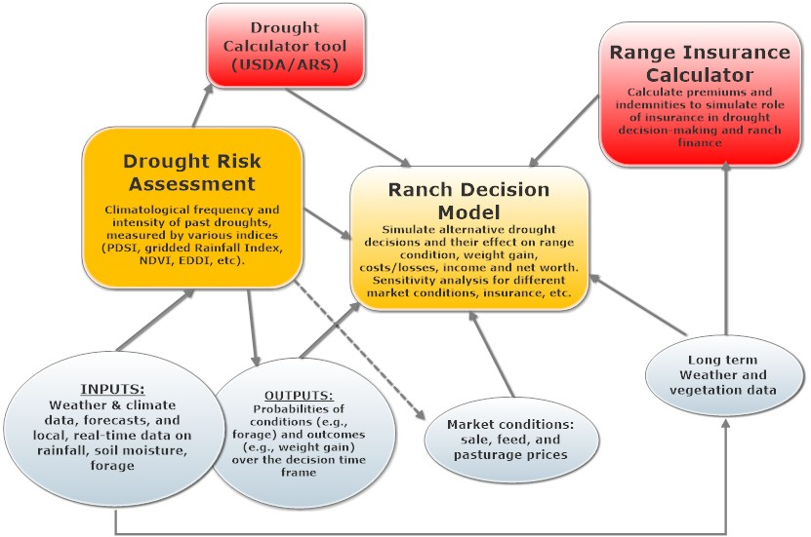

## Model Description

## Simulations

Climate inputs, drought measures, and probability of drought sequences….using ARS calculators and climate data

Ranch scenarios: actual year sequences played through a model with representative ranches,

sensitivity analysis to examine how ranges of drought impacts, feed prices, sale prices, etc. interact, and what sources of uncertainty (and additional information) are important.

Test range index insurance for its interaction with other choices and risk management strategies, as well as whether we see any hint in the simulations that range index insurance tends to encourage the response behavior commended in the literature, e.g., earlier de-stocking decisions, or maybe just the opposite?

Integrated analyses:

How skillful of a drought forecast would be needed to change a default decision? What likelihood in that forecast would make a difference?

Fig 2. Expected value of range insurance for Scenario I: 3,000 acre ranch, 600 head, NE Colorado, 2002 weather across probabilities that drought will continue past decision point (June) and trigger insurance.

# Results

## Drought Risk

## Drought decisions

## Drought Insurance

## Integrated simulations

Carande, V.G., Bartlett, E.T., Gutierrez, P.H. (1995) Optimization of rangeland management strategies under rainfall and price risks. Journal of Range Management 48, 68-72.

Committe on Economics of Range Use and Development, (1966) Economic Research in the Use and Development of Range Resources, in: Council, W.A.E.R. (Ed.). Western Agricultural Economic Research Council, Denver, CO.

Knutson, C., Haigh, T. (2013) A Drought-Planning Methodology for Ranchers in the Great Plains. Rangelands 35, 27-33.

National Drought Mitigation Center, (2011) Managing Drought Risk on the Ranch: A Planning Guide for Great Plains Ranchers. University of Nebraska, Lincoln, Nebraska, p. 39.

Ritten, J.P., Frasier, W.M., Bastian, C.T., Gray, S.T. (2010a) Optimal Rangeland Stocking Decisions Under Stochastic and Climate-Impacted Weather. American Journal of Agricultural Economics 92, 1242-1255.

Ritten, J.P., Frasier, W.M., Bastian, C.T., Paisley, S.I., Smith, M.A., Mooney, S. (2010b) A Multi-Period Analysis of Two Common Livestock Management Strategies Given Fluctuating Precipitation and Variable Prices. Journal of Agricultural and Applied Economics 42, 177-191.

Rodriguez, A., Taylor, R.G. (1988) Stochastic modeling of short-term cattle operations. Amer. J. Agr. Econ. 70, 121-132.

Stafford Smith, D.M. (1992) Stocking rate strategies across Australia: or, how do you cope with drought? Range Management (Newsletter of The Australian Rangeland Society) 92, 1-3.

Torell, L.A., Murugan, S., Ramirez, O.A. (2010) Economics of Flexible Versus Conservative Stocking Strategies to Manage Climate Variability Risk. Rangeland Ecology & Management 63, 415-425.